Krugman Module 23 – Money, Types, Functions
Check Your Understanding
- No, it’s near money but it’s not universally accepted.
- They are less liquid ie. Less easily accessible.
- Commodity money has issues of transport and production.
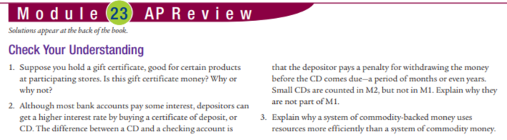
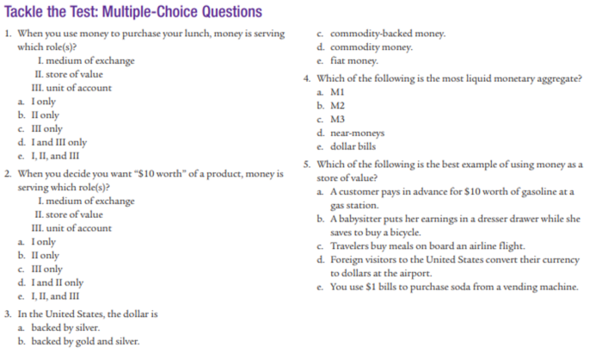
MC: 1.e 2.c 3.e 4.a 5.b
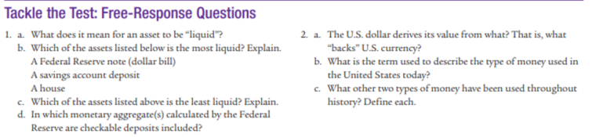
2. a. Its official status given by the US Government.
b. Fiat money. Commodity money-money that has intrinsic value in other uses.
Commodity backed money – money that has no intrinsic value but can be converted into valuable goods on demand.

